Tatur’s Midnight Madness.

Friday, July 5, 2013

How does one come to the point of running a 50 mile race and how do they survive it? I'm still not exactly sure.
Todd Raney and I completed the Garmin marathon in April and shortly thereafter decided that we wanted to take on more of a challenge. We needed something to train for so that we were "forced" to stay in the running groove and continue to push ourselves. I did some research and was intrigued by the challenge of an ultramarathon and Todd has never said “no” to any racing challenge! I read several reports from people claiming that an ultramarathon easier to run that a marathon. With the ultra, you are forced to run at a slower pace and take walk breaks. Although the total time can be well over twice that of a standard marathon, the more relaxed pace is actually easier on the body. A marathon still feels like a "race" in many ways -- pushing yourself to the max for the best possible finish time. An ultra is more about survival. Just completing one is a success. Time is not as much of a consideration. The average person has no idea what a good ultramarathon finish time is.
We decided to do it while we were still in pretty good shape from the marathon. We would only have to pick up the training slightly and find one several weeks out.
After some research and feedback, we settled on the Tulsa Area Trail & Ultra Runners Midnight Madness 50 miler. It's a relatively flat course, making it easier for a first-timer. The midnight start gets the race underway at the coolest point of the day. The course is relatively flat, with just one up and down hill near the midway point of the course. The downside might be that the loops are actually 10.3 miles, so the race distance is actually 51.5 miles…because 50 miles just isn't quite enough! I jokingly claimed that they should extend the race by an extra 9/10th of a mile so we could get a complete double marathon in.
The ultra-training was more relaxed than the advanced marathon training plan we had been doing. We dropped from running 6 days a week, back to 5. And during the week we just needed to run about 20 miles over three days -- no set amount of miles each day. The big change was on the weekends. The plans try to get you used to being on your feet for extended periods of time. We typically would have a 10-12 mile run on Saturday and a longer run on Sunday. For our training we had one 26 mile run and two 30 milers.
From the beginning, our first and only goal was to finish the race. We had debated a finish time goal and thought we could be done in about 12 hours. We just had no idea what to expect when the race is 20 miles further than either of us had ever run.
To convince my family to let me participate, I had to make it a mini vacation. So we went to Tulsa on Wednesday afternoon and spent a couple days being tourists. Thursday my kids ran the Tulsa Firecracker 5k. It was all I could do to keep myself from running it as well, but I did the smart thing (for a change) and just watched.
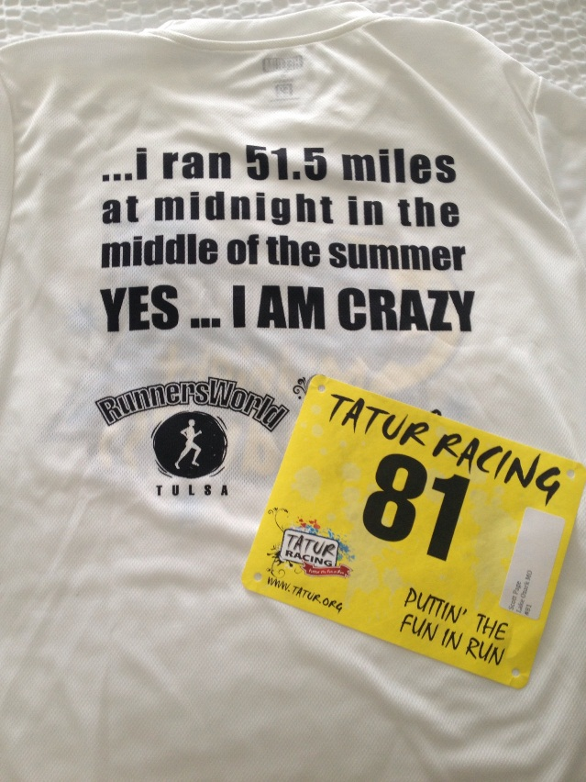
On Friday, Todd woke up at 4:00am and made the 4 hour drive to Tulsa. We went to packet pickup at 10:00am and got our bibs and race t-shirt. I wanted to put the race shirt on right then and there, but didn’t want to jinx it. However, that sealed the deal for finishing the race. To wear that shirt honorably we would going to have to complete all 5 laps.
We drove over to the start finish line to get a look at part of the course, then went to the movies to take our mind off the task at hand.
We decided on a large lunch at Carabba’s for some final carb loading and went back to the hotel to rest. I checked the TATUR Facebook page that afternoon and they had a post saying “We are ready for you! Quit checking FB and get some sleep. You are running 50 miles at midnight tonight at Tatur' Midnight Madness 50”. I took that as a sign that it was try to nap. Todd took about a 30 minute nap. I laid down for an hour but couldn't sleep, the race kept running through my mind. The adrenaline was already flowing.
We didn't eat dinner. The research I had done suggested eating a few calories before a night run (treating it like breakfast before a long morning run) so I had some Fig Newtons, a Clif bar, and a few lighter snacks, along with 3-4 bottles of water.
We left the hotel about 9:30pm and made the 15 minute drive to 41st and Riverside. Parking was going to be at a premium so we wanted to get there earlier. Even two hours from the start we grabbed one of the last close parking spots.
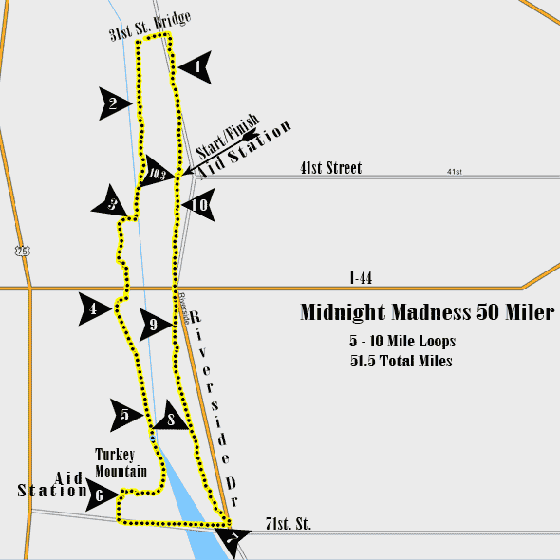
The weather was ideal at the start time, in the mid 70s. The forecast call for the temperature to drop to about 70 degrees by 6:00am before jumping quickly as the sun came up, with it hitting mid to upper 80s by noon. Everyone we talked to that had participated in the race before commented on how much better the weather was going to be than in previous years. In 2011 temperatures exceeded 100 at noon and the heat index was almost 110.
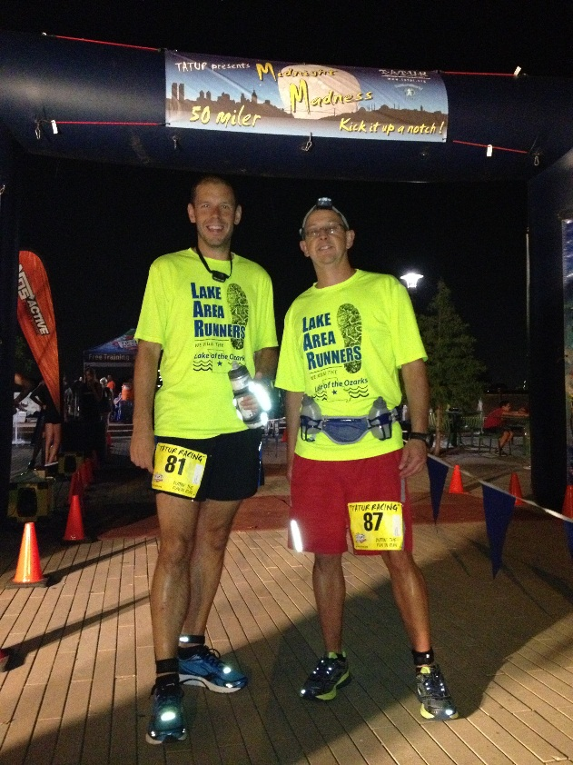
After arriving, we checked in and got our timing chip and just hung out and waited. The organizers had a pre-race meeting at 11:45pm to go over last minute instructions and safety. We all lined up just before midnight, the starting gun fired at 11:59pm, and we were off.
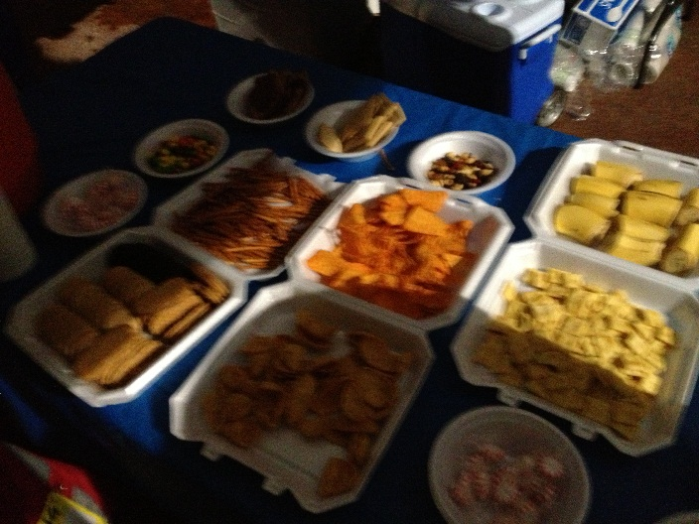
I was a little concerned that doing the same course for 5 laps would be boring, but it really made no difference. The first two laps were in the dark (we were required to wear headlamps for at least the first lap) so we couldn’t really see what we were passing or what we were missing. It started getting lighter on the third lap. The final two laps were in daylight. In addition, the organizers had us alternate directions after each lap. That allowed participants to keep track of where the other runners were. The course also offered a wide variety of scenery, crossing the Arkansas River twice, and running through parks, trails, and wooded areas.
Another concern was going to be the lack of sleep. Staying awake is one thing, but constantly being on the move throughout the night is another. However, once the adrenaline started flowing at the start of the race, I never felt the need to go to sleep. Fatigue didn’t set it until the race had been over for a few hours.
We really had no set plan for the race. We knew it would be a run/walk combo and to finish in 12 hours we would need to maintain an overall pace around 14 minutes per mile. We started off faster than we should have but with the cool air and the adrenaline, the sub 11:00 min pace felt like nothing. In addition, we hoped that by running a little faster at the start we could give up more time later.
The first lap was completed in 1 hour and 56 minutes and felt super easy. We really couldn’t finish this thing in less than 10 hours could we? Of course not.
We stopped at the start-finish aid station for about 5 minutes and headed back out. Starting the second lap we maintained the same pace at the start. About halfway through the lap Todd mentioned that he would not be able to keep that pace and we probably need to slow down. He wasn’t feeling quite right. So we walked a while to save energy.
As the next 5 miles progressed it was obvious that Todd was starting to struggle. We didn't know what was causing his troubles but at some point, he began to think that he had been drinking too much water. They always say to never do anything different during a race that you didn't do during training, but we did. During our training, we would run from spot to spot and drink when we stopped. For the race, we decided late that we should carry water with us. If the weather was going to be hot and we were going to be out for hours on end, we didn't want to get thirsty or dehydrated and not have immediate access to water. Todd had bought a water belt and used it frequently early on. He was basically drowning himself during the first lap and now it was catching up with him.
We finished the 2nd lap in 2 hours and 15 minutes. It was just before 4:10am. When we got to the aid station, the situation deteriorated pretty quickly. Todd rested for a while, changed all his clothes, and tried to feel better, but nothing seemed to work. I thought he might give up right then and not be able to finish. He looked terrible. At least he knew what was wrong at that point (or thought he did).
There were two manned aid stations on the course, and they were well stocked with water, Gatorade, beer, and a wide variety of snacks -- Doritos, corn chips, cookies, pretzels and more, as well as sandwiches, fruit, as well as first aid items. The volunteers, who always make or break a race, were great to deal with. They suggested Todd have a couple peppermints to help settle his stomach.
After 30 minutes he felt slightly better (or at least good enough to get started again) and we were back on the trails around 4:40am. He tried to cut back on the amount of fluids he was taking in, but probably cut back too much and stopped drinking as much as he needed. It's such a fine line.
We walked most of the 3rd lap as Todd tried to regain his energy and feel better. The third lap came in at 2 hours and 50 minutes. It was then just after 7:00am.
It appeared that we had turned a corner by then and Todd said if we could take the 4th lap easy we would try to push it on the final lap and make up some time.
We walked almost all of the 4th lap. However, Todd had stopped making progress at some point and it was clear he was just hanging on for the finish. I know he was getting frustrated with my walking pace, which was sometimes under 13 min/mile, but I found that early on, the faster I walked, he managed to keep up the pace with me. It was my subtle way of pushing him as hard as I could. We finished the 4th lap in 2 hours 30 minutes, a slight improvement over lap 3. It was now about 9:30am and we were over 40 miles into the race. To that point, the race had been such a whirlwind, even though he was struggling, that we barely noticed we had gone so far already.
On the 5th lap, my son and daughter, Ryan and Reagan, joined us as pacers, but our hoped for 12 hour finish was just about out of the question. Todd was a zombie at that point. He had nothing left and it was all we could do to keep him walking. The kids tried to encourage him, but I think they were just annoying him even though he says they helped. Ryan dropped out after 6 miles. It was getting warmer and he was getting bored with all the walking. Reagan stuck with us the entire 10 miles. She and I walked ahead of Todd, with Reagan occasionally turning around to yell, “Come on, Todd”, but it didn’t help. We stopped from time to time to let him catch up, and then would take off again. After the race, I asked the kids their thoughts on Todd's condition and they both said he acted like he was dead. Todd says the last 4 miles were the worst.
With all this talk of Todd's condition, I probably should say that I really didn't think he was in any danger at any point. I think any runner that's done longer distances had had one of those days where you feel like you can’t take another step and all you want to do is finish. If I had thought he was in real danger, I would have had him pulled from the race. He was obviously doing way more than he wanted, but I was confident he was going to make it.
He told me a few times to leave him and just finish the race and come back, but we had promised each other than we were finishing together. The only exception would be if one of us was hospitalized. Fortunately, he didn't get to that point.
We walked the entirety of the last lap and came across the finish line at 12:42pm. It was all Todd could do to shuffle across the line.
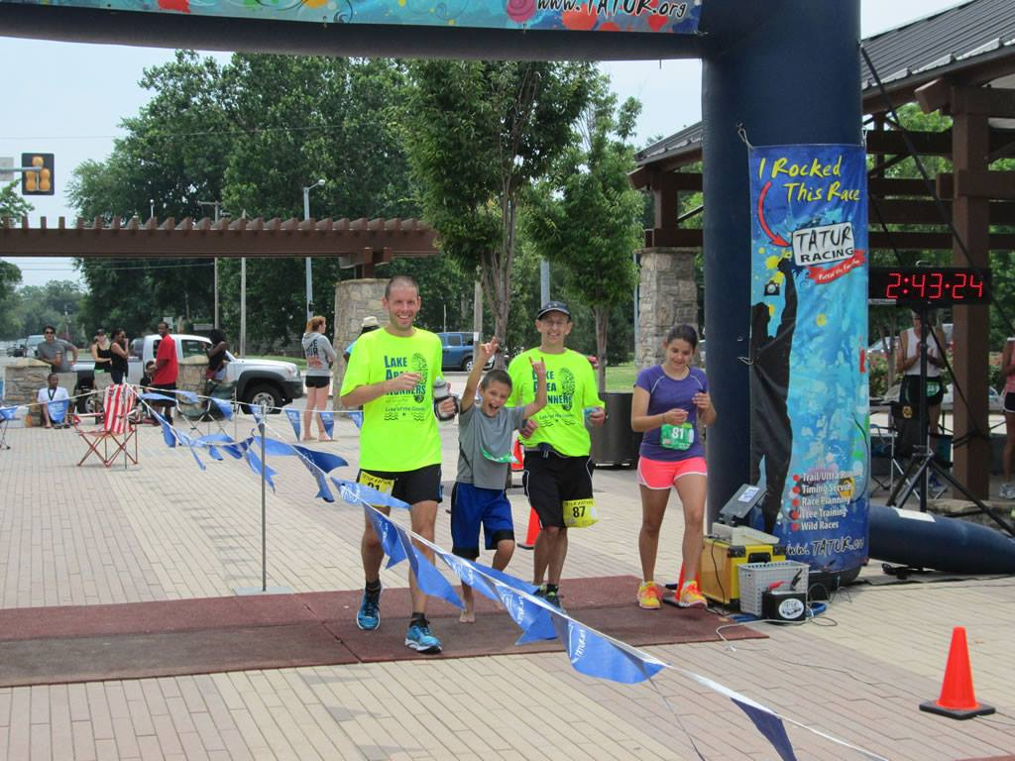
Our primary goal was completed….we finished!
I grabbed a drink and a snack. Todd first sat down at a table and laid his head down for about 10 minutes. Then he moved to a retaining wall to lay down. After 20 minutes there, he felt good enough to move around and we drove back to the hotel.
My family and I drove back to the Lake after the race. I did sleep a good portion of the way. Todd stayed in Tulsa until the next morning and then drove back. The recovery time was much quicker than expected. We both were back running by Tuesday after the race.
So, what’s next? Well, after telling me multiple times during the race that he hated it and would never do another one, and being miserable for most of it, Todd’s first text to me on Sunday morning was, “I have to run another one!”
Now that we have completed our first ultramarathon, we are looking for redemption. We now know what to expect and are looking at a fall 50 miler where temperatures might be a little cooler. Todd also wants a race that starts in the morning. We know how to run the race now and know how we need to train. We expect our goal time for the next one will be less than 11 hours and should be easily attainable.
I feel confident in saying that anyone who has completed a full marathon, can do an ultra. We would be happy to train with anyone or discuss the process more if someone thinks they might want to give one a try.

