**Rise and Shine for Kyleigh**

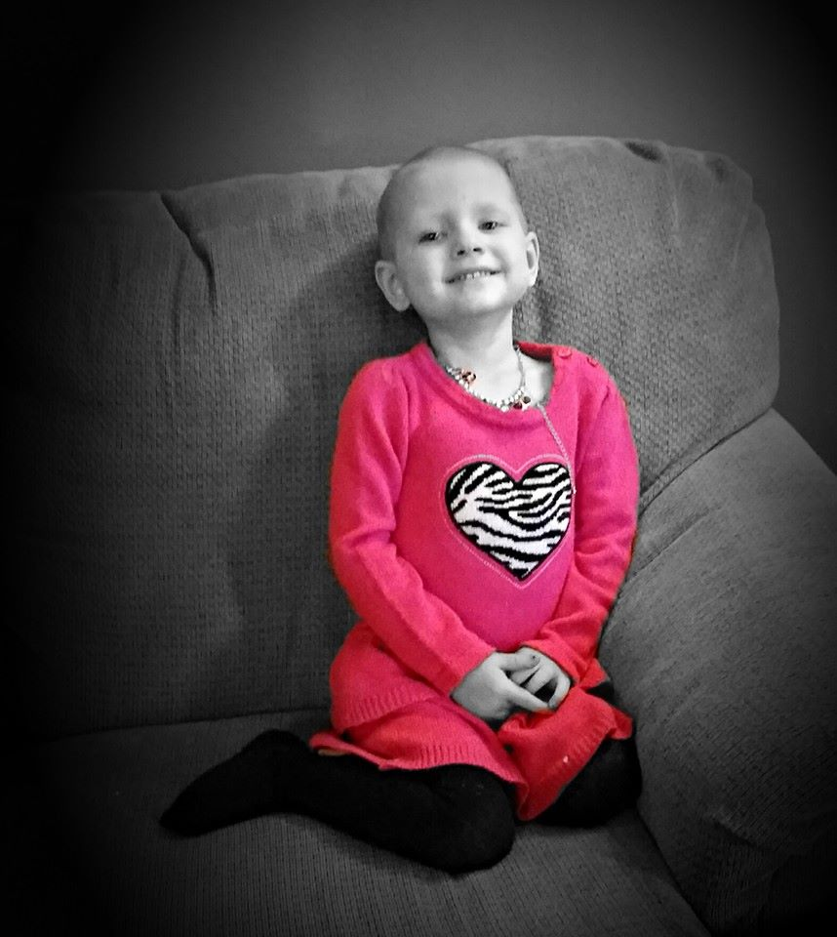

**5k & Half Marathon**

September 19, 2015

Kyleigh Phillips was born December 5th, 2011. On January 23of 2014 Kyleigh was diagnosed with Stage 4 Neuroblastoma. After treatment and a brief time in full remission her cancer resurfaced in February of 2015. There is currently no known cure. We would like to ask for your support in helping the family deal with the financial difficulty in these trying times.



**While we appreciate any and all financial support we do realize that not everyone is able to support us in this way. One way everyone can help is to lift Kyleigh and her family up in prayer. While doctors have done all they can do we know god can do all things. Please help us spread the word in remembering Kyleigh in your prayers.**

Kyleigh’s family and all of us at Rise N Shine would like to thank you for your support. Please call or email Curtis or Tami Wehmeyer to set up sponsorship or answer any questions. Curtis may be reached at 573‐480-8880 or [curtsboyz23@yahoo.com](mailto:curtsboyz23@yahoo.com) or Tami can be reached at 573-836-4364 or tami.wehmeyer@gmail.com

Thank You and God Bless,

Curtis & Tami Wehmeyer

Rise and Shine Race Coordinators