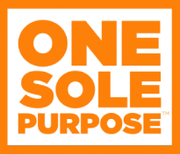
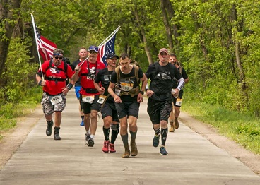
WANT TO RUN A RACE AND MAKE A DIFFERENCE IN THE LIFE OF A CHILD??? CHECK OUT THE ONESOLPURPOSE 5K/10K/12 MILE RUN AND RUCK
Join us on 6/20/20 (virtually of course) for Pulaski County's first annual OneSolePurpose 5k/10k/12 mile Run and Ruck. Healthy Futures Pulaski County, a Coalition under the Pulaski County Health Center, has partnered with One Sole Purpose of Springfield to provide new shoes to the elementary age students in Pulaski County's Title 1 Schools beginning with the Dixon Elementary School.
Register to run the 5k and one student receives a new pair of shoes. Register for the 10k and two children receive a new pair of shoes!! You get the picture right? And you can donate on top of that to provide even more shoes!!! Simply complete your race on June 20 where you are or anytime before 7/05/2020 and we will mail your bling!
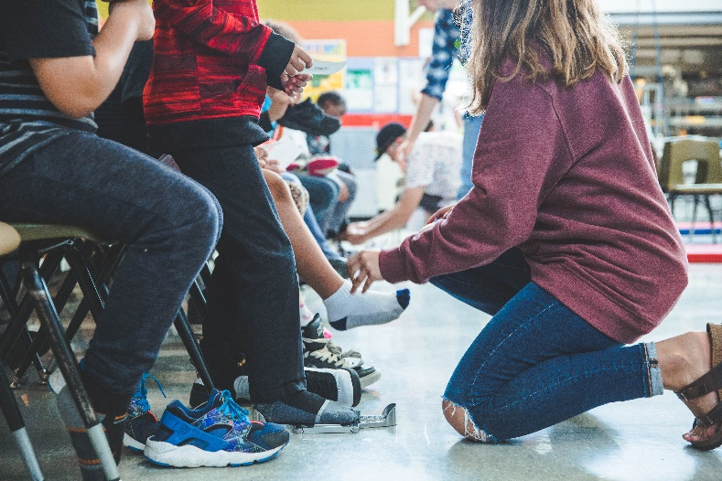
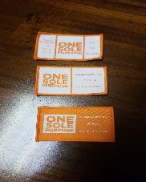
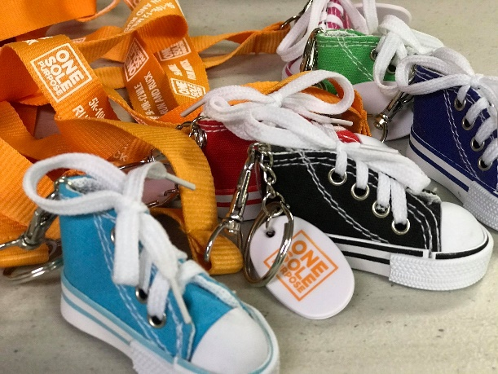
Don't want to run but would like to help?? Click on the registration link and then click DONATE on the right to make your donation. We thank you!!!!!
And for those of you that enjoy rucking solo or as part of a team, there's an option for you too!!! Ruck alone or on a team of 5 for 3.1.miles, 6.2 miles or 12 miles. You'll have fun and provide a new pair of shoes to a local student in the process!!! That's a Win-Win right there!!! There will be individual Age Group Awards for all races and extra TEAM awards for the rucking division!! This will give you and your team bragging rights!!
All runners will receive a one-of-a-kind medal and all ruckers will receive a one-of-a-kind patch!
https://localraces.com/events/waynesville-mo/onesolepurpose-5k-10k-12-mile-ruck-and-run
Go to: https://localraces.com/events/waynesville-mo/onesolepurpose-5k-10k-12-mile-ruck-and-run to get signed up or make a donation today!!!

