Impact Medical Missions 5K/10K, Family walk/run
When: May 16th 8:30 5K/10K 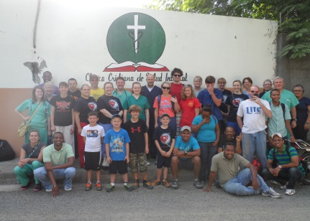
8:45 walking start 7:30- 8:15 registration

Where: Linn Creek Industrial side

Cost: $20 individual or $40 family

Free t-shirt if signed up by May 1st
T-shirts available with race day registration until gone
There will be medals offered

Last Name __________________ First Name __________________

Address _________________________________________________________

Email address: _________________ Phone number ________________

Date of birth ___________________ Age on race day _______________

Shirt size S M L XL 2XL Kids M L Phone number ________________
Waiver: I know running a road race is potentially a hazardous activity. I agree to abide by any decision of a race official relative to my ability to safely complete the event. I assume all risks associated with participating in this event, including, but not limited to falls, contact with other participants, the effects of weather including moisture heat and or high humidity, traffic and the conditions of the road surface. Having read this waiver and knowing these facts and in consideration of Impact Medical Missions, Linn Creek City and all other sponsors, their representatives and successors from all claims or liabilities of any kind arising out of my participation in this event.

Signature_______________________________________________________
Please make checks payable to Impact Medical Missions
Please mail checks to Impact Medical Missions 1475 Golfview Lane Osage Beach, MO 65065
All money raised goes towards a medical and construction mission trip to the Dominican Republic August 1, 2015

