
Date: June 2, 2012
6^{TH ANNUAL} Dennis Scheiderer
5k Walk/Run
Dear Community Supporter,

This is an invitation to participate in a very important event and an opportunity to support our children.

Eldon Kiwanis is inviting the community to participate in our Sixth Annual 5k Walk/Run, and we are seeking runners/walkers. Kiwanis is a worldwide service organization, sharing the challenge of community and world by improving people’s lives….our children’s lives.

Like the years in the past we are making this event fun for the whole family. Snacks, Awards and a great time don’t miss out! 6:30 am Walkers Registration * 7:10am Walkers Start
7:05 am Runners Registration *7:45am Runners Start

Name Age Please circle size add $1.50 for the XL sizes

Child Sizes: S M L Adult Size: S M L XL XXL
Name (additional family member) Age
Child Sizes: S M L Adult Size: S M L XL XXL

Sign up for: Prices:
Address Adult: Ages 14 & above – Advanced $ 15.00
Additional family member $ 10.00
Adult: Ages 14 & above – Not Pre-registered $ 20.00
Child 14 & Under FREE

Method of Payment: Check Total:
Cash
Phone Please Register before May 7th to guarantee shirt size or to order extra Adult size $9.50 + $1.50 for XL sizes, Kids $7.50

______________________________________________________
Email This year’s shirts look like:
Location:  Public Safety Building  111 S. Oak St., Eldon, MO  Awards Ceremony – shortly after race. To be held at the start/finish line | 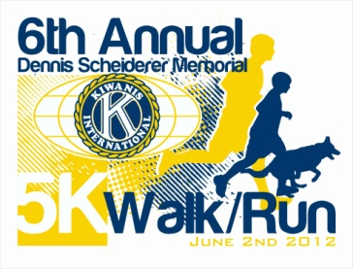
Contact
Alecia Etter
27 Blue Ridge Dr.
Eldon MO 65026
573-375-1978 – email: alecia@cpr2theRescue.com
Make Checks Payable to: Eldon Kiwanis

